from matplotlib import pyplot as plt

from sklearn import datasets

from sklearn.tree import DecisionTreeClassifier

from sklearn import tree

# Prepare the data data

iris = datasets.load_iris()

X = iris.data

y = iris.target

# Fit the classifier with default hyper-parameters

clf = DecisionTreeClassifier(random_state=1234)

model = clf.fit(X, y)

# 1

text_representation = tree.export_text(clf)

print(text_representation)

# if you want to save the tree...

with open("decistion_tree.log", "w") as fout:

fout.write(text_representation)

# 2

fig = plt.figure(figsize=(25,20))

_ = tree.plot_tree(clf,

feature_names=iris.feature_names,

class_names=iris.target_names,

filled=True)

# if you want to save the tree...

fig.savefig("decistion_tree.png")

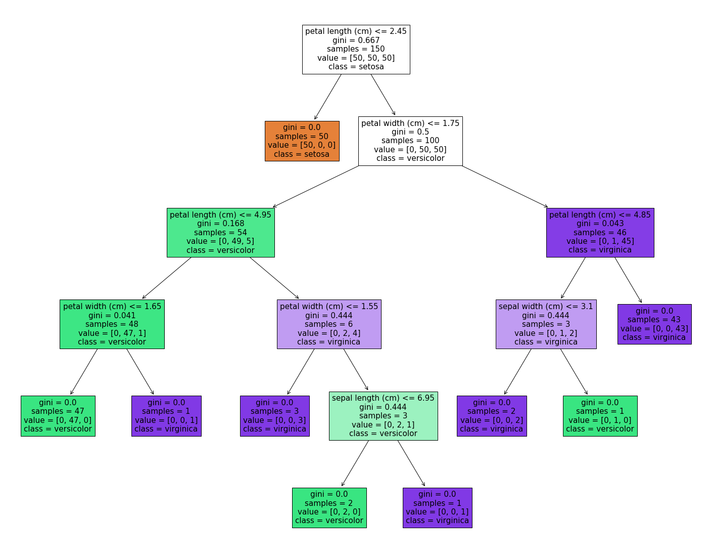

# 3

import graphviz

# DOT data

dot_data = tree.export_graphviz(clf, out_file='C:\\Users\\ryans\\OneDrive\\Desktop\\Briefcase\\PDFs\\1-ALL PYTHON & R CODE SAMPLES\\Decision Tree Visualized\\tree.dot',

feature_names=iris.feature_names,

class_names=iris.target_names,

filled=True)

from sklearn import datasets

from sklearn.tree import DecisionTreeRegressor

from sklearn import tree

# Prepare the data data

boston = datasets.load_boston()

X = boston.data

y = boston.target

# To keep the size of the tree small, I set max_depth = 3.

# Fit the regressor, set max_depth = 3

regr = DecisionTreeRegressor(max_depth=3, random_state=1234)

model = regr.fit(X, y)

# 1

text_representation = tree.export_text(regr)

print(text_representation)

fig = plt.figure(figsize=(25,20))

_ = tree.plot_tree(regr, feature_names=boston.feature_names, filled=True)

# 2

fig = plt.figure(figsize=(25,20))

_ = tree.plot_tree(regr,

feature_names=boston.feature_names,

filled=True)

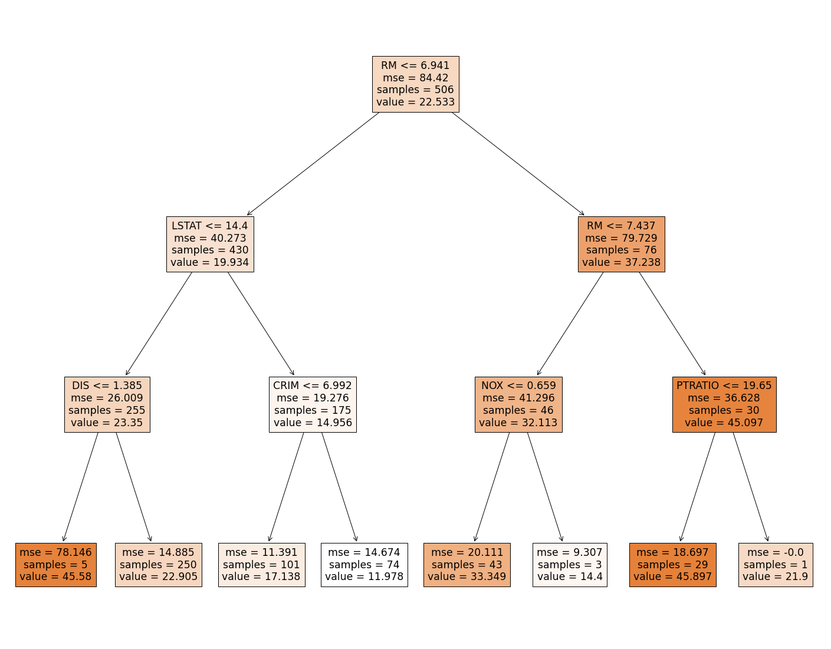

# <https://mljar.com/blog/visualize-decision-tree/>